**East End Taste Magazine**

<https://eastendtastemagazine.com>

Vanessa Gordon, Founder & Publisher

Guest – Barbara Mattera

Sample Article – [A Guide to the Gold Coast Mansions of Long Island](https://eastendtastemagazine.com/gold-coast-mansions-of-long-island-guide/)

150k monthly combined reach, including social media, newsletter subscribers, digital platform, and bi-monthly radio segment with Long Island Radio Broadcasting

51k [Instagram](https://www.instagram.com/eastendtaste/) Followers

12.5k [Facebook](https://www.facebook.com/EastEndTaste) Followers

**Online Magazine Overview**

East End Taste Magazine is a go-to source for culinary-focused sustainable travel, food and beverage focused coverage of Hamptons and North Fork of Long Island and London. The elevated publication focuses on restaurant highlights, chef news, travel, events, specialty food, lifestyle, wellness and fashion.

**Personal Details**

Vanessa oversees the day-to-day operations across all platforms, including social media. East End Taste Magazine comprises of a small full-time, part-time and freelance staff. Her writing has appeared in publications including Thrillist, Hamptons Magazine, Beach Magazine, Pregnancy & Newborn, Psychology Today, The Daily Meal, the Independent Newspaper, and many others. She has been featured or quoted in the New York Times, Condé Nast Traveler, Parents Magazine, New York Post, The Daily Beast, Medium, AM New York, SELF Magazine, The Points Guy, SheKnows, ClearVoice, and many more. She also has a bi-monthly radio segment with Long Island Radio Broadcasting's 102.5 WBAZ. Vanessa is the Founder and Host of Taste & Escape: The Hamptons Brunch, an annual event that brings together business owners, executives, philanthropists, entrepreneurs, actors, media personalities, and more. Vanessa earned her Master of Arts in Education from New York University, and studied abroad at the Institute of Education and at University of Oxford's St. Edmund's College. She lives in New York with her husband, two children, and two cats.

**Dietary Restrictions**

No dietary restrictions, but she is following a careful, mostly wheat/gluten free/low sugar diet, but she is flexible.

**Travel Details**

**Flight:** Delta Airlines, Confirmation #HJUMVL

Monday, 6/27 - Departing LGA at 9:00 am on Flight #4698, Arriving Knoxville 11:21 am

**Airport Transfer:** Sean Oellien (865-228-1709); will meet outside of baggage claim (dark gray Kia Soul)

**Room Type:** Two Queen

**Room Confirmation:** 985004

**Tuesday Excursion Request:** Visit [Ijams Nature Center](https://www.ijams.org/) for (an easy) hike or possibly a kayak excursion; stop in at [Post Modern Spirits](https://postmodernspirits.com/) for a tasting

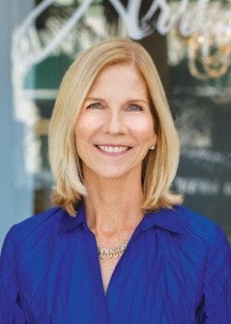**Sarasota Magazine/Houstonia Magazine** <https://www.sarasotamagazine.com>

<https://www.houstoniamag.com>

Susan Burns, Travel & Outdoor Editor

Guest – None

52k combined print circulation and online reach (Sarasota Magazine)

130k combined print circulation and online reach (Houstonia Magazine

**Publication Overview**

Both Sarasota Magzine and Houstonia Magazine are published monthly and target upscale readership in their respective markets, with emphasis on travel in every issue, as well as culinary highlights, arts and culture, style and shopping, news and city life, travel, health and wellness, and home and real estate.

**Journalist Profile**

Susan is a seasoned editor and writer - she recently stepped down from the Editor-in-Chief position at Sarasota Magazine after 20+ years to fill the role of Travel & Outdoor Editor. A journalist in Sarasota and Manatee counties for 36 years, Susan has been covering the people, issues, trends, events and places that define the region. She was also the founding editor of *(941)CEO*, a bi-county business magazine and the e-newsletter *Biz Daily*. In addition to *Sarasota Magazine*, the top-awarded magazine in the state in 2019 and 2020, she is leading *Sarasota Magazine* through a major expansion into the digital world. She started her career as a daily newspaper reporter at the *Bradenton Herald.* She is interested in highlighting Knoxville and The Tennessean Hotel as the ideal weekend jumping off spot for visits to the Smoky Mountains and will highlight the direct flight option to Knoxville from nearby St. Pete/Clearwater in the Sarasota edition.

**Dietary Restrictions**

None

**Travel Details**

**Flight:** Allegiant Airlines Confirmation #BY2ZZH

Sunday, 6/26 – Departing St. Pete/Clearwater at 8:52 am on Flight #2616, Arriving Knoxville at 10:28 am

Wednesday, 6/29 – Departing Knoxville at 1:00 pm on Flight #2667, Arriving St. Pete/Clearwater at 2:37 pm

**Airport Transfer:** Sean Oellien (865-228-1709); will meet outside of baggage claim (dark gray Kia Soul)

**Room Type:** King

**Room Confirmation:** 983517

**Monday Morning Excursion Request:** Enjoy walking around Market Street/Downtown Gay Street for shopping and exploring the destination; stop in at [Knox Brew Hub](https://www.knoxbrewhub.com/) for complimentary tasting

**Tuesday Excursion Request:** Visit [Ijams Nature Center](https://www.ijams.org/) for (an easy) hike or possibly a kayak excursion; stop in at [Post Modern Spirits](https://postmodernspirits.com/) for a tasting;

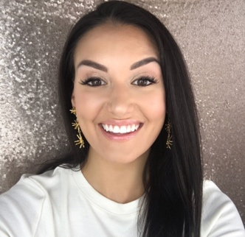[**Tonya Michelle**](https://www.instagram.com/tonyamichelle26/)

<http://www.tonyamichelle26.com>

<https://www.instagram.com/tonyamichelle26/>

Guest – Victoria Escobar

<https://www.instagram.com/victoria.i.escobar/?hl=en>

941k Instagram Followers

524k TikTok Followers

2+% Engagement Rate (industry standard)

**Influencer Overview**

Tonya Michelle blog is lifestyle blog and social network focusing on beauty, fashion, food, lifestyle, home, and travel In addition to including content for her website, she also highlights her family, beauty tips, shopping, and more on her social pages. Tonya’s post generate an average of 17k interactions each, with followers making purchasing and travel decisions based upon her recommendations. Tonya is Virginia-based.

**Secured Coverage**

Tonya has agreed to a blog post/highlight of the trip along with one static, in-feed post per night of stay with geo tags (2-4 total) with 5+ stories and TikToks per day, within two weeks of the visit. She will also share photos for hotel use following her post.

**Dietary Restrictions**

None

**Travel Details**

Driving, Arriving Sunday, 6/26 ($259 media rate for Sunday night) and departing Wednesday, 6/29

**Room Type:** Panoramic Double King Room

**Room Confirmation:** 985003

**Tuesday Excursion Request:** Visit [Ijams Nature Center](https://www.ijams.org/) for (an easy) hike or possibly a kayak excursion; stop in at [Post Modern Spirits](https://postmodernspirits.com/) for a tasting

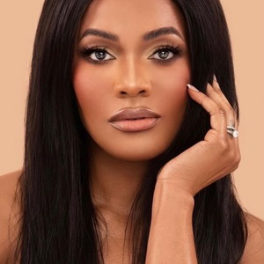**Ashlei Jarrett**

<https://www.ashleijarrett.com/about>

<https://www.instagram.com/posh_ash/>

Guest – Husband, Rondley Jarrett

18k Instagram Followers

**Influencer Overview**

Ashlei created her website in 2021 to share with the public her love of fashion, beauty and travel. She began sharing her love of makeup and fashion through videos on Youtube, Instagram, and Tiktok. Within a year, she amassed a following of over 20K followers. Ashlei is New Jersey-based and lives with her husband and two children. In addition to content related to lifestyle, she highlights collabs, family, work, OOTD looks, and her inspirations on her social pages.

**Secured Coverage**

Ashlei has agreed to a blog post/highlight of the trip along with one static, in-feed post per night of stay with geo tags (2-4 total) with 5+ stories and TikToks per day, within two weeks of the visit. She will also share photos for hotel use following her post.

**Dietary Restrictions**

Rondley is allergic to shellfish and doesn not eat pork.

**Travel Details**

**Flight:** Delta Airlines

Monday, 6/27 - Arriving Flight #5440 at 5:09 pm

Wednesday, 6/29 – Departing Flight #4734 at 6:55 pm

**Airport Transfer:** Sean Oellien (865-228-1709); will meet outside of baggage claim (dark gray Kia Soul)

**Room Type:** Single King

**Room Confirmation:** 985005

**Tuesday Excursion Request:** Visit [Ijams Nature Center](https://www.ijams.org/) for (an easy) hike or possibly a kayak excursion; stop in at [Post Modern Spirits](https://postmodernspirits.com/) for a tasting

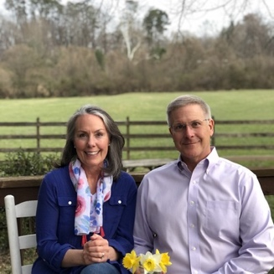**West Knoxville Lifestyle Magazine**

<https://citylifestyle.com/westknoxville>

Marc Rochelson - Owner and Publisher

Guest – None

ADD IN PRINT CIRCULATION AND ONLINE REACH FROM CISION

ADD IN FULL PAGE AD RATE

2.5K [Instagram](https://www.instagram.com/westknoxvillelifestyle/) followers

1.4K [Facebook](https://www.facebook.com/WestKnoxvilleLifestyle) followers

**Publication Overview**

West Knoxville Lifestyle Magazine is a premier monthly publication created an exclusive inspired by the community. This publication aims to connect the residents to the people, places, and things that make our city special. Publications of the magazine focus on topics such as Arts+ Culture, Auto+ Marine, Beauty, Education Entertainment, Event Planning, Finance, Fitness, Food, and so many more.

**Journalist Profile**

Marc Rochelson is the owner and publisher of West Knoxville Lifestyle Magazine. He has 20 years of award-winning sales and business development experience with a passion for all things local. He is driven by a sense of urgency, entrepreneurial style, customer focus, and a results-oriented approach to driving customer satisfaction. Marc has won various awards, including being named number one out of 230 person GE healthcare IT sales force in 2011, the GE USCAN President’s Award in 2022, and more. Marc graduated from the University of Tennessee in 1996 with a BS in Engineering Science.

**Dietary Restrictions**

None

**Visit Details**

Complimentary valet; meeting Nancy in hotel lobby at 5 pm on Monday, June 27 for a quick meeting ahead of happy hour and dinner with the group; Marc is experiencing Park Tavern for a local restaurant highlight and will discuss other editorial opportunities while meeting with TMG on-property.