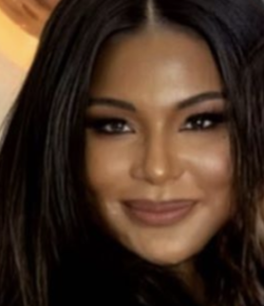
Vanessa Marc
Vanessa is in the top list of celebrity skincare experts and estheticians as for years she has perfected her treatments. Her consistent clients include; Zendaya, Chloe Bailey, Tiffany Haddish, Winnie Harlow, NBA James Harden, Nicky Hilton and many more. She works with all genders and advocates for all genders to learn more about skin care.

Social Reach
- Website: https://vanessamarc.com
  - Instagram: 56.5k followers

Sample Coverage: Vanessa mentioned in articles for her work
- Haute Living
- Hypebae
- Insider

Mr. C Beverly Hills Media Visit June 24-26, 2022, Friday-Sunday
In exchange for media stay experience, Karla will create press and get recognized on popular outlets. Vanessa will request that her clients that has come through will tag the hotel and share the comments or hashtags we prefer in the Mr. C Beverly Hills robe and balcony views.

Vanessa plans on doing a pop-up at Mr. C and having spa treatments for people( VIPs and Media) available the day before the BET Awards. Vanessa’s PR form is working on exclusives with Vogue and Harper’s Bazaar, who will come to the hotel and feature the services and Mr. C Beverly Hills with the angle of a day in the life of awards season.

Notes – Vanessa is traveling with ___
Dietary Restrictions – None
Preferred Wine Varietal – TBD
Vanessa’s Mobile – ____

Mr. C Beverly Hills Visit
Two-night complimentary stay in a Classic Suite; Reservation Confirmation #_______
- Waived hotel room fees & taxes for two nights
- Flowers in guest room
- Complimentary parking
- Tip is included in F&B experience

Welcome Amenity – Bottle of White sparkly wine - Prosecco Brut and bottle of water with note from Brock; considering a fresh flower arrangement
Arrival Time – _____
Hotel Tour – ______

Mr. C Beverly Hills Complimentary Experiences
Friday, June 24
__pm Arrival – early check-in is prepared
_____ evening appointments

Saturday, June 25
____ appointments

Sunday, June 26
11 am Departure

