Kateri Dion
Kateri is a model influencer, reaching 118K followers on Instagram with a bachelor's in nutrition and health science. She is also the voice and name behind Instagram about health KL Health Club.

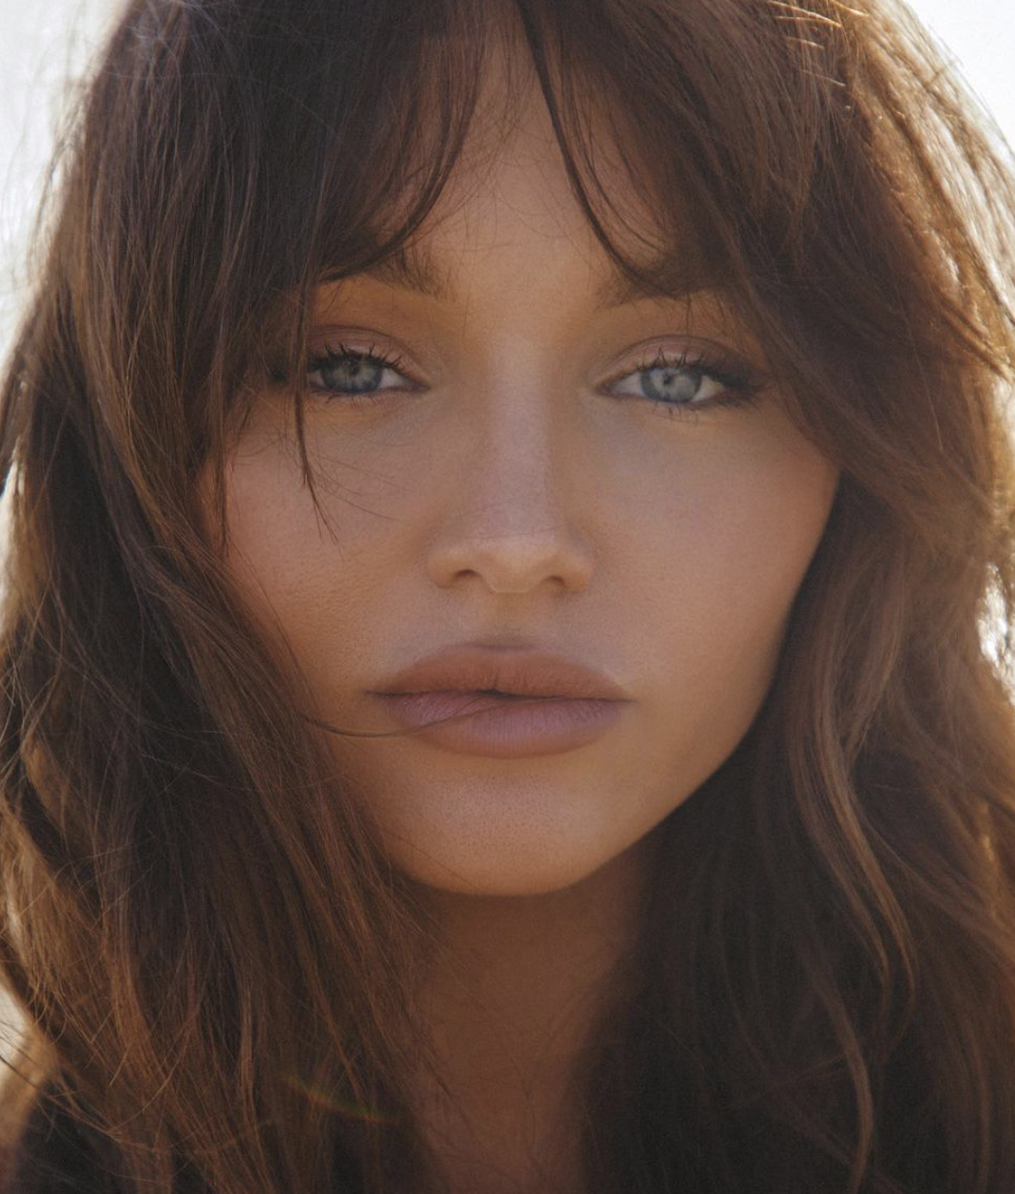
Social Media Platforms
Instagram- https://www.instagram.com/kateridion/?hl=en
Twitter- https://twitter.com/kateri_dion?lang=en

Reach
- 181k followers on Instagram
- 2, 972 followers on klhealthclub

Sample Coverage:

Mr. C Beverly Hills Visit is Saturday-Sunday, June 25-26, 2022
Secured Coverage
- At least 5 Instagram stories
- At least 1 static Instagram Feed Post with Geo-Tag
- Image assests for use

Notes – Kateri will be traveling Dominic Nora
Dietary Restrictions – None
Preferred Wine Varietal – ___________________
Kateri’s Mobile ________________

Mr. C Beverly Hills Visit
One-night complimentary stay in a Premium Beverly King guest room- confirmation number is #116282158
- Waived Hotel Room Fee & Taxes
- Complimentary Parking
- Tip is included in F&B experiences

Welcome Amenity – Decadent sweet with bottle of wine and note from Brock
Arrival Time –__________ pm on Saturday, June 25

Mr. C Beverly Hills Complimentary Experiences

Saturday, June 25
______ pm Arrival
______ pm Hotel Tour – Greeted and toured by Brock
__7:30____ pm The Restaurant at Mr. C – Dinner for two

Sunday, June 26

______ am Daybed by pool

11 am Departure

