**Outlet** [The Wine Shutter](https://www.thewineshutter.com/features)

**Stay Date**  Sunday, Oct. 23 -Tuesday, Oct. 25, 2022

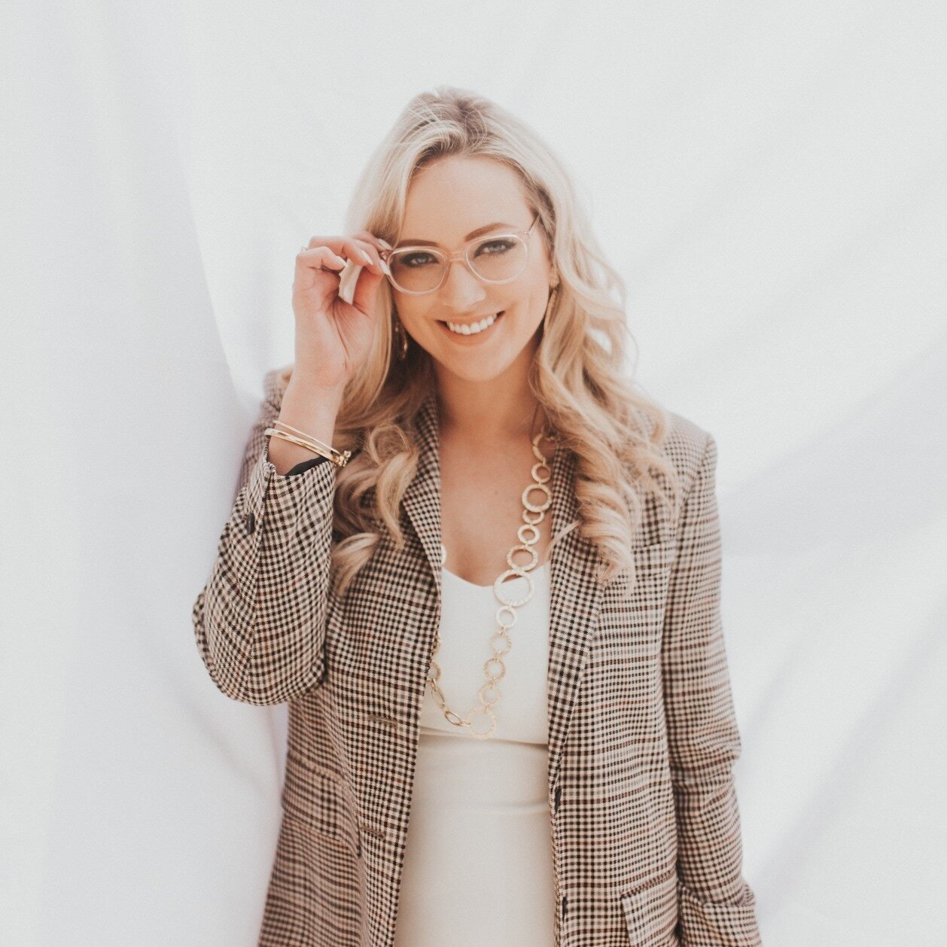

**Influencer** Chelsea Smith

**Reach**  [Personal Instagram](https://www.instagram.com/chelseaericasmith/): 83.3K followers

Instagram Engagement: 1.25%

[The Wine Shutter Instagram](https://www.instagram.com/thewineshutter/): 49.5K

Instagram Engagement: 2.01%

[Wedding Photography Instagram:](https://www.instagram.com/urbanbay/) 11K

Instagram Engagement: 0.86%

**Outlet Profile** The Wine Shutter is a Wine and Travel Blog with Blog +Pro Photography focusing on Wine Marketing and Photography, Hotel and Restaurant Blog and Reviews and Branding and Counseling. She highlights the services she offers for hotels, wineries along with branding and marketing packages along with her blog and reviews and partners she has worked with in the past.

**Influencer Profile** Chelsea is a professional photographer, influencer, and wine/travel blogger from Nashville and the owner and chief photographer of The Wie Shutter. Chelsea spent her formative years drink wine in secret as it was a breach of contract at George Fox University, a private Christian College. Over the eight years following. Chelsea was able to grow her love for culture people, and taste of wine and the beauty that surrounds it. Now she is working as an Award-Winning Pro Photographer, Marketing Consultant, Social Media Influencer and Copywriter Helping Wineries, Hotels, and Restaurants around the Globe.

**Angle** The Tennessean Hotel requests a post per night of stay with geo tags along with 5+ stories on IG per night of stay (so roughly 10-15 stories or reel/recap) within two weeks of your visit. We like to have access to the images for use following the visit and have an image release form for signature on that aspect.

**Sample Features** [Thompson Nashville- a luxe + boutique hotel](https://www.thewineshutter.com/features/thompson-nashville)

[Noelle Nashville](https://www.thewineshutter.com/features/noelle-nashville)

[Daily Pours](https://www.thewineshutter.com/features/daily-pours)

[Best Brunch in Nashville](https://www.thewineshutter.com/full-blog/top-4-brunch-spots-in-nashville)

[Top 6 Boutique Oregon Wineries Worth Exploring](https://www.thewineshutter.com/full-blog/top-6-boutique-oregon-wineries)

**Notes** Chelsea will be traveling with her spouse, John Dana Slater

### The Tennessean Hotel to Provide:

**Hotel Rate/Fee** Two- night stay in king room

Confirmation:  #984513.

**Room Type** Best available, king room

**Food & Beverage**

**Amenity** Welcome note and signature candle in writer’s room upon arrival

**Client Interaction**

**Dietary Needs**

**Media Stay Agenda**